A000-Asia-China-Hongshan-C Dragon-Black-Jade-3500-2200 BCE

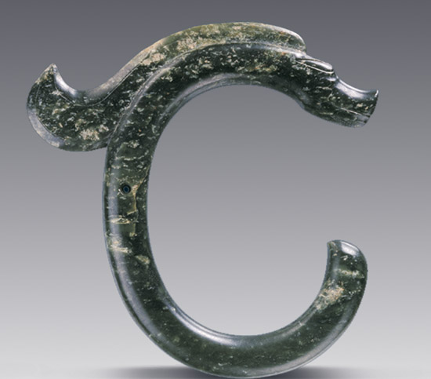

C龙黑皮玉，高=C dragon Black jade, High

**c-dragon**

only two Hongshan c dragons have been unearthed, neither in rigorously controlled situations allowing carbon dating using accompanying material with biological content, but the stylistic and processing similarity with recognized Hongshan jade objects provides reasonable confidence that they belong to the same era

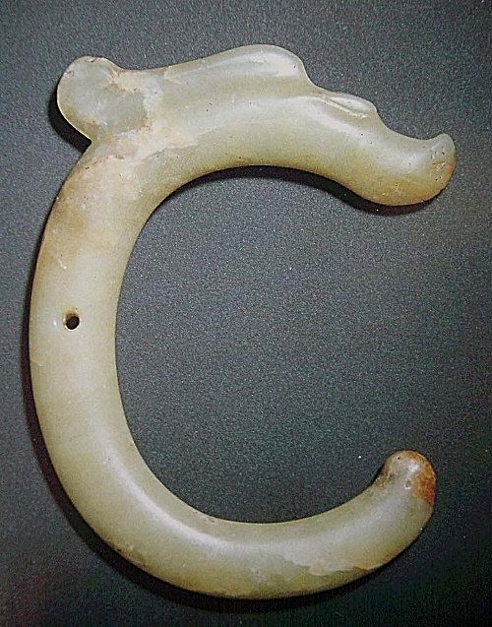

these were found in southeast inner mongolia within the wide region of Hongshan culture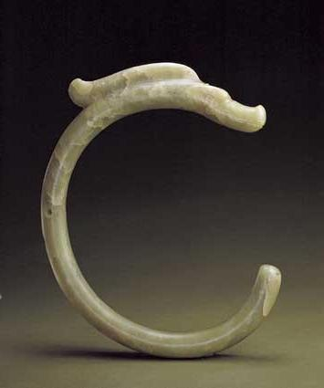

collected privately some years ago then donated to the Beijing Palace Museum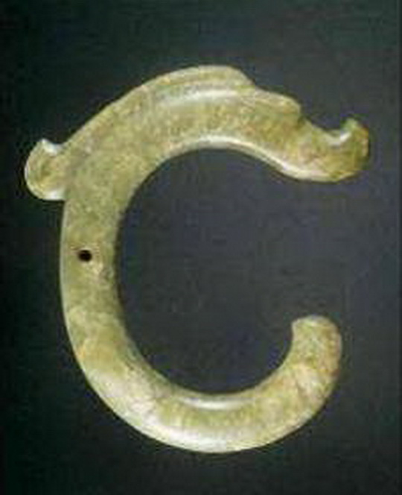

also from the Fu collection but auctioned off, current whereabouts unknown

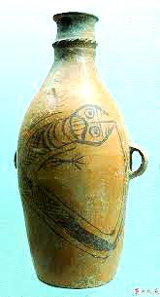

Left and below: from other regions but related in concept: end is begin, thing and nothing are the same, fish with human face/snake chewing plant show a different manifest of the dragon

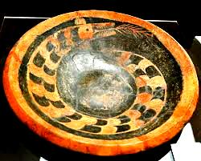

**pig dragons and other creature figures**